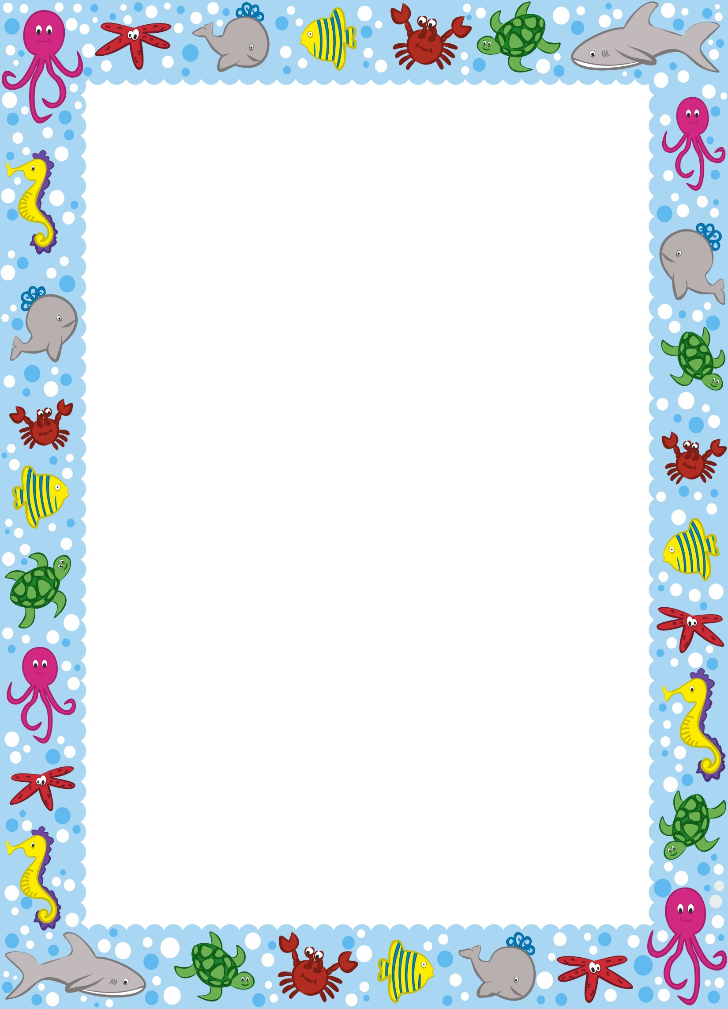

July 19-23

Join Grove Hill Public Library at our Summer Reading Program, Tails and Tales! We have some exciting ideas to share with you to make your Summer spectacular! There will be two sessions: Pre-K- 1st grade from 10:00-11:30 and 2nd- 4th grade from 1:00-2:30.

There will be registration forms at Grove Hill Public Library.

108 Dubose Ave, Grove Hill, AL 36451

(251) 275-8157

\*\* If you child wishes to checkout a book, they will need to get a library card for free.

2021 Summer Reading Program

