PCA Mill Scholarship Program

APPLICATION Due Date: JAnuary 15, 2025

MILL HR CONTACTS:

Leea Sullivan: 251-246-8686

Ketrenia Crenshaw: 251-246-8214

Scholarship Program Details

Packaging Corporation of America (PCA) is excited to offer three scholarships to local students interested in pursuing a degree in the engineering field. This scholarship (“PCA Scholarship”) is intended to assist with tuition, on campus housing/dorm room, and the cost of required textbooks and lab fees for each enrolled class.

*“PCA has a Strong and proud presence in the local area. We appreciate the talent of our students and are excited to invest in your education in hope of securing talent for the future of PCA!”*

*Mill Manager*

The qualified applicant must:

1. Be a graduating senior accepted to attend a 4-year university acceptable to mill management. Acceptance letter to an accredited college or university must be provided.
2. Intend to enroll full-time with a declared major in either Chemical, Electrical, Paper Science/Engineering, Mechanical, Industrial, Civil or Environmental Engineering.
3. Reside within 50 miles of the mill location.
4. Have at least a 3.0 GPA average on a 4.0 system. An official high school transcript must be provided.
5. Successfully complete the application and submit it by the deadline.
6. Complete a mill visit, which will include a tour and panel interview.

Scholarship Details:

1. The Selected Student understands that these scholarship funds, up to $30,000.00 per academic year, will be awarded on an after-aid basis. This means that this scholarship will fund the remaining balance after all other scholarship and financial aid monies have been awarded to the student.
   1. Covered expenses include:
      1. Tuition (Mill management, can, in its discretion, increase the scholarship amount in the event of tuition increases.)
      2. Housing/dorm room provided by the college or university (off campus rentals that are not provided and invoiced by the school are not reimbursable).
      3. Class and lab fees (including fees or tuition required for any class tied to a required internship or co-op completion)
      4. Books
   2. An invoice from the school must be provided to the Mill HR contact after the class “drop” deadline date has passed for each semester. The mill will not process the invoice for payment until the final class load for the semester has been determined in order to avoid over payment.
2. The Selected Student must declare their major in Chemical, Electrical, Paper Science/Engineering or Mechanical Engineering as soon as allowable per the university requirements and maintain the university’s requirements for each year of the PCA Scholarship.
3. The Selected Students must maintain a minimum 3.0 GPA at their university and meet any program-specific requirements of the university.
   1. Must provide an official transcript with grades at the end of each term to HR.
   2. Selected students whose GPA for the semester falls below the minimum of 3.0 will be placed on probation for the following term.
   3. Should the student fail to regain a 3.0 GPA for the probationary term, the Mill Management Team will review the circumstances of the student’s academic situation, and will have the sole discretion to terminate the student’s eligibility to receive further disbursements from the PCA Scholarship.
4. At the end of each academic year the Mill Management Team will evaluate the progress of each Selected Student to determine whether each Selected Student will continue to receive the award into the next academic year.
5. If during any period of employment with PCA the Selected Student’s employment performance does not meet the expectations of the Mill Management Team, PCA at its discretion may end the Selected Student’s participation in the PCA Scholarship.
6. Selected student may have the opportunity to work as a Summer Student at the mill during the summer prior to their Freshman year of college, if work is available.
7. Selected student may have the opportunity to work as an intern or co-op at the mill during the course of their studies, if a position is available.
8. Following the successful completion of the Mill Scholarship Program and graduation from their engineering degree program, the Selected Student may be offered a full-time position with PCA if available, at the sole discretion of the Mill Management Team.
9. The Mill Management Team maintains the discretion to discontinue providing funds under the PCA Scholarship in the event that the Selected Student is found to have engaged in conduct that violates PCA’s Code of Ethics, the university or college’s code of conduct or is illegal.

Selection Process & Timeline:

* *September/October* – PCA Mill representatives meet with area high schools to inform them of the PCA Mill Scholarship Program.
* *December* – Completed applications are due and must be returned to the Mill HR Department by the deadline listed on the front page of this document. *Late applications will not be accepted.*
* *January/February* – Mill Management Team meets to review applications and select candidates to move on to the interview round.
* *March* – Selected candidates are invited to the Mill for a panel interview and a tour of the mill (tours may be conducted virtually as needed). *If the acceptance letter to the college or university was not provided in the initial application, the student must bring this to the panel interview/tour or send it to the Mill HR contact prior.*
* *April* – Mill Management Team make final decisions on which applicants will be awarded the Mill Scholarships.
* *May* – Mill Manager and HR Manager attend the selected Mill Scholarship winners’ high school scholarship award ceremony and/or invite the students to an on-site Academic Signing Day at the mill.

*As the sponsor of your scholarship, we are investing in your future!*

Scholarship Essay Topic:

Topic 1: The products of the pulp and paper industry can be seen all around us. Describe how the industry has impacted your life, and what interests you about a career in pulp and paper.

Topic 2: Why should PCA choose you to receive this scholarship, and how would you apply your chosen engineering discipline in a career at PCA?

Essay Requirements:

* Type your essay and include your name, address and phone number.
* Essays are due at the time of your application.  
  *Late submissions will not be accepted.*
* Essays must be at least 500 words and include discussion of *both* of the above topics.

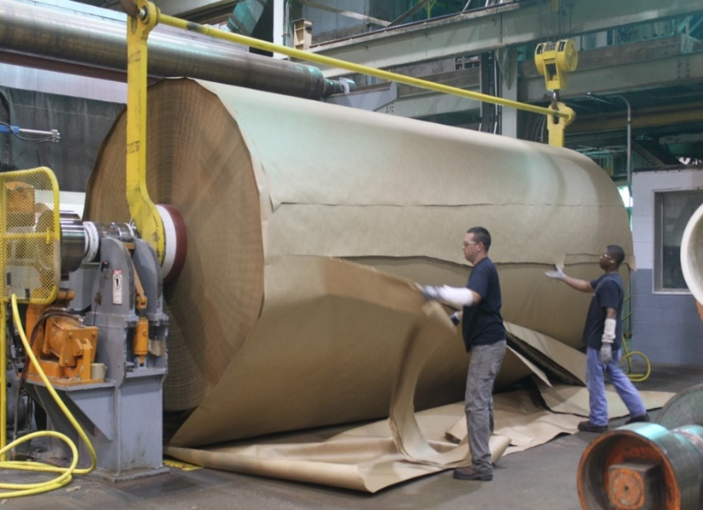Applications should be turned in by   
­­­January 15, 2025   
Applications can be dropped off at PCA Main Security, attention Human Resources or email to -[leeasullivan@packagingcorp.com](mailto:leeasullivan@packagingcorp.com)

All applications will be reviewed by the management team.

The selected recipients will be notified via phone and scheduled for a panel interview and a mill tour.

The winners of scholarships will then be notified.

The student and their parents will be invited to participate in our Annual Academic Signing Day at the mill.

*Please contact Mill HR if you have any questions.*

Scholarship Application

Full Name (Printed):_______________________________________

High School: _____________________________________________

Home Address: ________________________________________________

Home Phone: _____________________Cell Phone:______________________

Email Address: _________________________

Your GPA: ____________

College you plan to attend: _____________________________________

Intended Major: ______________________________________________________

Please attach the following, in order:

* This application form.
* Cover Letter, addressed to scholarship committee.
* Resume, including list of extracurricular activities.
* Transcript from your high school.
* Essay, as described on the previous page.
* Acceptance letter from an accredited 4-year college or university (must be provided by the on-site interview date if not included in the application).

*I understand that scholarships are awarded at PCA’s sole discretion, and that PCA may revise or revoke this program at its sole discretion. I agree to adhere to all scholarship policies as outlined above, and that I must meet and maintain qualifying criteria to be eligible for scholarship funds. Furthermore, I understand that this scholarship covers undergraduate degree expenses only.*

Student’s Signature: ___________________________ Date: _________________