Clarke Prep Break
Sunday | Monday | Tuesday | Wednesday | Thursday | Friday | Saturday
 | 1 | 2 | 3 | 4 | 5 | 6
 | 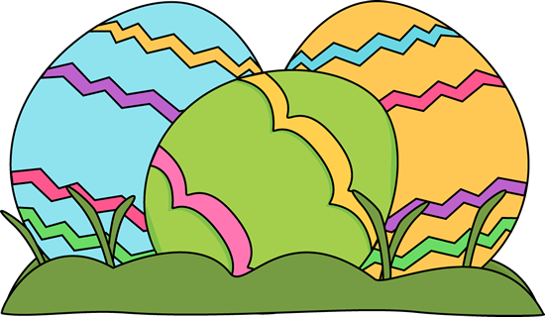  EASTER  HOLIDAY | Sausage Biscuit  Mozzarella Sticks  Pretzel & Queso  Cereal & Milk | Gravy/Plain Biscuit  Churro  Mozzarella Sticks  Cereal & Milk | Sausage Biscuit  Cinnamon Roll  Mozzarella Sticks  Cereal & Milk | Big Mama Breakfast  French Toast Breakfast  Cereal & Milk
7 | 8 | 9 | 10 | 11 | 12 | 13
 | Chicken Biscuit  Mozzarella Sticks  Nachos & Queso  Cereal & Milk | Sausage Biscuit  Mozzarella Sticks  Pretzel & Queso  Cereal & Milk | Gravy/Plain Biscuit  Churro  Mozzarella Sticks  Cereal & Milk | Sausage Biscuit  Cinnamon Roll  Mozzarella Sticks  Cereal & Milk | Big Mama Breakfast  Pancake Breakfast  Cereal & Milk
14 | 15 | 16 | 17 | 18 | 19 | 20
 | Chicken Biscuit  Mozzarella Sticks  Nachos & Queso  Cereal & Milk | Sausage Biscuit  Mozzarella Sticks  Pretzel & Queso  Cereal & Milk | Gravy/Plain Biscuit  Churro  Mozzarella Sticks  Cereal & Milk | Sausage Biscuit  Cinnamon Roll  Mozzarella Sticks  Cereal & Milk | Big Mama Breakfast  French Toast Breakfast  Cereal & Milk
21 | 22 | 23 | 24 | 25 | 26 | 27
 | Chicken Biscuit  Mozzarella Sticks  Nachos & Queso  Cereal & Milk | Sausage Biscuit  Mozzarella Sticks  Pretzel & Queso  Cereal & Milk | Gravy/Plain Biscuit  Churro  Mozzarella Sticks  Cereal & Milk | Sausage Biscuit  Cinnamon Roll  Mozzarella Sticks  Cereal & Milk | Big Mama Breakfast  Pancake Breakfast  Cereal & Milk
28 | 29 | 30 | 1 | 2 | 3 | 4
 | Chicken Biscuit  Mozzarella Sticks  Nachos & Queso  Cereal & Milk | Sausage Biscuit  Mozzarella Sticks  Pretzel & Queso  Cereal & Milk | Gravy/Plain Biscuit  Churro  Mozzarella Sticks  Cereal & Milk | Sausage Biscuit  Cinnamon Roll  Mozzarella Sticks  Cereal & Milk | MAY DAY  NO SCHOOL

